**Experiment No :1**

**TABLE**

**AIM:**  Program to model a simple HTML file to demonstrate the use of tables.

<HTML>

<HEAD>

<TITLE>html</TITLE>

</HEAD>

<BODY>

<CENTER>

<BR><BR>

<H4>INTERNET TECHNOLOGY 4</H4>

<H4>Specification Table with Hours and Marks</H4>

<TABLE BORDER=2 ALIGN=CENTER BGCOLOR=LIGHTBLUE>

<TH ROWSPAN=2><B><CENTER>Unit No.</CENTER></B></TH>

<TH ROWSPAN=2><B>Unit Title</B></TH>

<TH ROWSPAN=2><B>Teaching Hours</B></TH>

<TH COLSPAN=4><B>Distribution of Theory Marks</B></TH>

<TR>

<TD>R Level</TD>

<TD>U Level</TD>

<TD>A Level</TD>

<TD>Total Marks</TD>

<TR>

<TD>I</TD>

<TD>Introduction to Internet Technology</TD>

<TD><CENTER>2</CENTER></TD>

<TD><CENTER>4</CENTER></TD>

<TD><CENTER>4</CENTER></TD>

<TD><CENTER>0</CENTER></TD>

<TD><CENTER>8</CENTER></TD>

</TR>

<TR>

<TD>II</TD>

<TD>Basics of HTML & CSS</TD>

<TD><CENTER>6</CENTER></TD>

<TD><CENTER>0</CENTER></TD>

<TD><CENTER>2</CENTER></TD>

<TD><CENTER>6</CENTER></TD>

<TD><CENTER>8</CENTER></TD>

</TR>

<TR>

<TD>III</TD>

<TD>Active Server Pages 3.0</TD>

<TD><CENTER>6</CENTER></TD>

<TD><CENTER>4</CENTER></TD>

<TD><CENTER>8</CENTER></TD>

<TD><CENTER>0</CENTER></TD>

<TD><CENTER>12</CENTER></TD>

</TR>

<TR>

<TD>IV</TD>

<TD>Server Side Coding with VBScript and XML</TD>

<TD><CENTER>8</CENTER></TD>

<TD><CENTER>2</CENTER></TD>

<TD><CENTER>4</CENTER></TD>

<TD><CENTER>8</CENTER></TD>

<TD><CENTER>14</CENTER></TD>

</TR>

<TR>

<TD>V</TD>

<TD>ASP Objects & Components</TD>

<TD><CENTER>10</CENTER></TD>

<TD><CENTER>4</CENTER></TD>

<TD><CENTER>4</CENTER></TD>

<TD><CENTER>6</CENTER></TD>

<TD><CENTER>14</CENTER></TD>

</TR>

<TR>

<TD>VI</TD>

<TD>Accessing database eith ASP & ADO</TD>

<TD><CENTER>10</CENTER></TD>

<TD><CENTER>4</CENTER></TD>

<TD><CENTER>4</CENTER></TD>

<TD><CENTER>6</CENTER></TD>

<TD><CENTER>14</CENTER></TD>

</TR>

<TR>

<TD> </TD>

<TD><B><CENTER>Total</CENTER></B></TD>

<TD><B><CENTER>42</CENTER></B></TD>

<TD><B><CENTER>18</CENTER></B></TD>

<TD><B><CENTER>26</CENTER></B></TD>

<TD><B><CENTER>26</CENTER></B></TD>

<TD><B><CENTER>70</CENTER></B></TD>

</TR>

</TABLE>

</CENTER>

</BODY>

</HTML>

**RESULT**

The html file is executed and verified.

**OUTPUT**

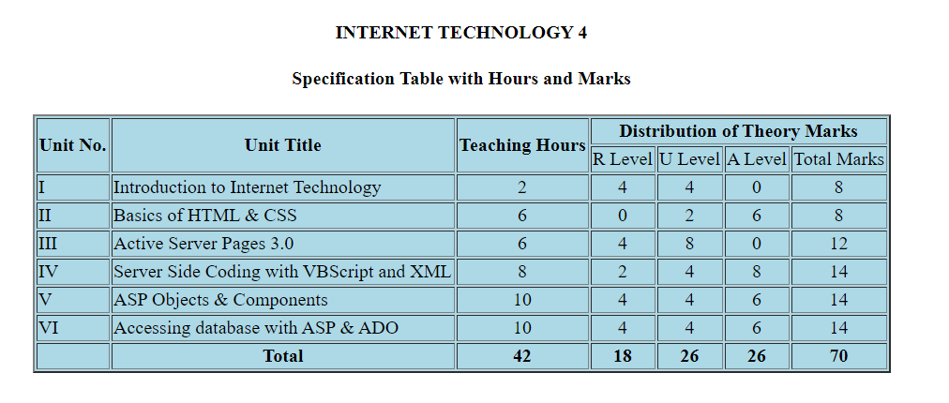

**Experiment No :2**

**LINK**

**AIM**: To Create a HTML file to link to different HTML pages

SOURCE CODE

<html>

<body bgcolor=lightblue>

List of Software Learning Websites

<ul>

<li><u>ASP Tutorial-W3Schools</u></li>

<a href="https://www.w3schools.com/asp" target="_blank">www.w3schools.com/asp</a> </font>

<li><u>Classic ASP Tutorial & Articles-Web Wiz</u> </li>

<a href="https://www.webwiz.co.uk-Knowledgebase" target="_blank">www.webwiz.co.uk-Knowledgebase </a> </font>

<li><u>HTML Tutorial-W3Schools</u></li>

<a href="https://www.w3schools.com/html" target="_blank">www.w3schools.com/html</a> </font>

<li><u>CSS Tutorial</u></li>

<a href="https://www.csstutorial.net" target="_blank">www.csstutorial.net</a> </font>

<li><u>ADO Tutorial-W3Schools</u></li>

<a href="https://www.w3schools.com/ADO/default.asp" target="_blank">www.w3schools.com/ADO/default.asp</a> </font>

</ul>

</body>

</html>

**RESULT**

The html file is executed and verified.

**OUTPUT**



**Experiment No :3**

**FRAMES**

**AIM:** To Create a HTML page with different types of frames.

**SOURCE CODE**

<html lang="en">

<head>

<link rel="stylesheet" href="style.css">

<title>Mohandas College of Engineering & Technology</title>

</head>

<body>

<header>

<h2>Mohandas College of Engineering & Technology</h2>

</header>

<section>

<nav>

<h3>Navigation Menu</h3>

<ul>

<li><a href="#">MCA</a></li>

<li><a href="#">MBA</a></li>

<li><a href="#">M.Tech</a></li>

<li><a href="#">B.Tech</a></li>

<ul>

<li><a href="#">CSE</a></li>

<li><a href="#">EEE</a></li>

<li><a href="#">ECE</a></li>

<li><a href="#">BT</a></li>

<li><a href="#">CE</a></li>

</ul>

</ul>

</nav>

<content>

<br>

<p>

<center>

Mohandas College of Engineering & Technology (MCET) is an engineering and technology college located at the village Anad, Thiruvananthapuram district,Kerala, India. The college, which is affiliated ti the KTU, was establihed in 2002. Mohandas College is a project of the Mohandas Group of Companies and is managed by the VN Gangandharan Panikker Memorial Trust. The college has received ISO 9001:2008 certification.

</center>

</p>

</content>

</section>

</body>

</html>

Style.css

* {

box-sizing: border-box;

}

body {

font-family: 'Times New Roman', Times, serif;

}

header {

background-color: rgb(108, 231, 118);

padding: 50px;

font-family: 'Times New Roman', Times, serif;

text-align: center;

font-size: 20px;

color: rgb(0, 0, 0);

}

nav {

float: left;

width: 20%;

height: 750px;

background: rgb(204, 204, 204);

padding: 20px;

}

content {

float: left;

padding: 50px;

width: 80%;

font-size: larger;

font-weight: 900;

text-align: justify;

background-color: #f5f8c3;

height: 750px;

}

**RESULT**

The html file is executed and verified.

**OUTPUT**



**Experiment No :4**

**PREDEFINED FUNCTIONS IN A STRING AND MATH OBJECT**

**IN JAVASCRIPT**

**AIM:** To Create an HTML page to explain the use of various predefined functions in a string and math object in Javascript.

**SOURCE CODE**

<html>

<body>

<h2><b>JavaScript String Methods<b></h2>

<p>The length property returns the length of a string:</p>

<p id="p1"></p>

<p>The indexOf() method returns the position of the first occurrence of a specified text:</p>

<p id="p2"></p>

<p>The slice() method extract a part of a string

and returns the extracted parts in a new string:</p>

<p id="p3"></p>

<p>The substring() method extract a part of a string and returns the

extracted parts in a new string. </p>

<p>Extract Apple from the string"Intel, Apple,Windows"

<p id="p4"></p>

<p>Replace "Microsoft" with "Windows" in the "Please visit Microsoft!"</p>

<p id="p5">Please visit Microsoft!</p>

<p>Convert string to upper case: Hello World!</p>

<p id="p6">Hello World!</p>

<p>The concat() method joins two or more strings:</p>

<p> concatenate Hello and World!</p>

<p id="p7"></p><br><br>

<h2><b>JavaScript Math objects</b></h2>

<p>Math.round(x) returns the value of x rounded to its nearest integer:4.4</p>

<p id="p8"></p>

<p>Math.ceil() rounds a number <strong>up</strong> to its nearest integer:4.4</p>

<p id="p9"></p>

<p>Math.trunc(x) returns the integer part of x: 4.7</p>

<p id="p10"></p>

<p>Math.pow(x,y) returns the value of x to the power of y: 8^2 </p>

<p id="p11"></p>

<p>Math.sqrt(x) returns the square root of x: 84</p>

<p id="p12"></p>

<p>Math.sin(x) returns the sin of x (given in radians):</p>

<p>Angle in radians = (angle in degrees) * PI / 180.</p>

<p id="p13"></p>

<p>Math.min() returns the lowest value in a list of arguments:0, 150, 30, 20, -8, -200</p>

<p id="p14"></p>

<p>Math.random() returns a random number between 0 and 1:</p>

<p id="p15"></p>

<script>

var txt = "ABCDEFGHIJKLMNOPQRSTUVWXYZ";

var sln = txt.length;

document.getElementById("p1").innerHTML = sln;

var str = "Please locate where 'locate' occurs!";

var pos = str.indexOf("locate");

document.getElementById("p2").innerHTML = pos;

var str = "Samsung, Nokia, Oppo";

var res = str.slice(7,13);

document.getElementById("p3").innerHTML = res;

var str = "Intel, Apple,Windows";

var res = str.substring(7,12);

document.getElementById("p4").innerHTML = res;

var str = document.getElementById("p5").innerHTML;

var txt = str.replace("Microsoft","Windows");

document.getElementById("p5").innerHTML = txt;

var text = document.getElementById("p6").innerHTML;

document.getElementById("p6").innerHTML = text.toUpperCase();

var text1 = "Hello";

var text2 = "World!";

var text3 = text1.concat(" ",text2);

document.getElementById("p7").innerHTML = text3;

document.getElementById("p8").innerHTML = Math.round(4.4);

document.getElementById("p9").innerHTML = Math.ceil(4.4);

document.getElementById("p10").innerHTML = Math.trunc(4.7);

document.getElementById("p11").innerHTML = Math.pow(8,2);

document.getElementById("p12").innerHTML = Math.sqrt(64);

document.getElementById("p13").innerHTML =

"The sine value of 90 degrees is " + Math.sin(90 * Math.PI / 180);

document.getElementById("p14").innerHTML =

Math.min(0, 150, 30, 20, -8, -200);

document.getElementById("p15").innerHTML = Math.random();

</script>

</body>

</html>

**RESULT**

The html file is executed and verified.

**OUTPUT**

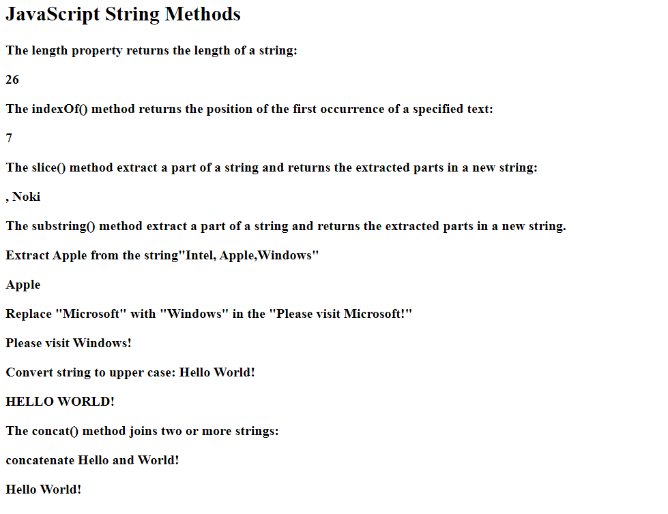

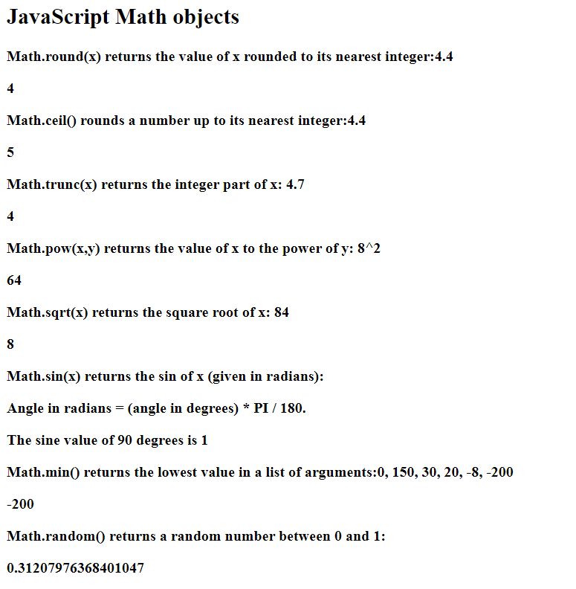

**Experiment No :5**

**JAVASCRIPT EVENT HANDLING**

**AIM:** To Create a HTML page to display a new image and text when the mouse comes over the existing content in the page using JavaScript event handling.

**SOURCE CODE**

<html>

<body>

<script type="text/javascript">

function mouseOver() {

document.getElementById("img").src = "image1.jpg";

}

function mouseOut() {

document.getElementById("img").src = "image2.jpg";

}

</script>

<form id="form1">

<div style="border: 1px solid #d2cece; width: 500px; height: 350px; text-align: center">

<h2>onmouseover and onmouseout javascript code </h2>

<br />

<a href="Onclick.html" target="_blank">

<img border="0" alt="Visit my site!" src="flowers.jpg" id="img" width="260" height="260"

onmouseover="mouseOver()" onmouseout="mouseOut()" /></a>

</div>

</form>

</body>

</html>

**RESULT**

The html file is executed and verified.

**OUTPUT**

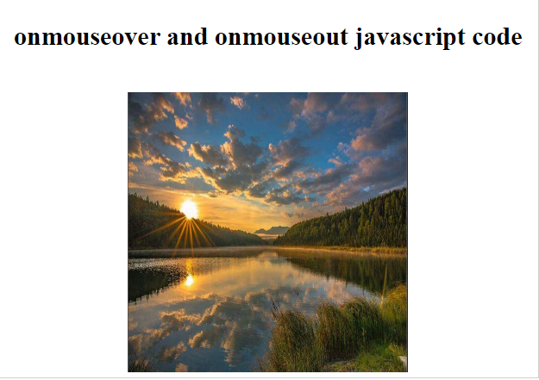

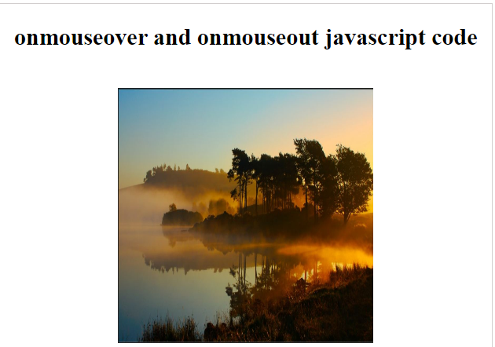

**Experiment No :6**

**FORM VALIDATION**

**AIM:** To Create a form program that collects the first name, last name, email, user id, password and confirms password from the user. All the inputs are mandatory and email address entered should be in correct format. Also, the values entered in the password and confirm password textboxes should be the same. After validating using JavaScript, In output display proper error messages in red color just next to the textbox where there is an error.

**SOURCE CODE**

<html>

<head>

<title>Form Validation</title>

<script type="text/javascript">

var divs = new Array();

divs[0] = "errFirst";

divs[1] = "errLast";

divs[2] = "errEmail";

divs[3] = "errUid";

divs[4] = "errPassword";

divs[5] = "errConfirm";

function validate()

{

var inputs = new Array();

inputs[0] = document.getElementById('first').value;

inputs[1] = document.getElementById('last').value;

inputs[2] = document.getElementById('email').value;

inputs[3] = document.getElementById('uid').value;

inputs[4] = document.getElementById('password').value;

inputs[5] = document.getElementById('confirm').value;

var errors = new Array();

errors[0] = "<span style='color:red'>Please enter your first name!</span>";

errors[1] = "<span style='color:red'>Please enter your last name!</span>";

errors[2] = "<span style='color:red'>Please enter your email!</span>";

errors[3] = "<span style='color:red'>Please enter your user id!</span>";

errors[4] = "<span style='color:red'>Please enter your password!</span>";

errors[5] = "<span style='color:red'>Please confirm your password!</span>";

for (i in inputs)

{

var errMessage = errors[i];

var div = divs[i];

if (inputs[i] == "")

document.getElementById(div).innerHTML = errMessage;

else if (i==2)

{

var atpos=inputs[i].indexOf("@");

var dotpos=inputs[i].lastIndexOf(".");

if (atpos<1 || dotpos<atpos+2 || dotpos+2>=inputs[i].length)

document.getElementById('errEmail').innerHTML = "<span style='color: red'>Enter a valid email address!</span>";

else

document.getElementById(div).innerHTML = "OK!";

}

else if (i==5)

{

var first = document.getElementById('password').value;

var second = document.getElementById('confirm').value;

if (second != first)

document.getElementById('errConfirm').innerHTML = "<span style='color: red'>Your passwords don't match!</span>";

else

document.getElementById(div).innerHTML = "OK!";

}

else

document.getElementById(div).innerHTML = "OK!";

}

}

function finalValidate()

{

var count = 0;

for(i=0;i<6;i++)

{

var div = divs[i];

if(document.getElementById(div).innerHTML == "OK!")

count = count + 1;

}

if(count == 6)

document.getElementById("errFinal").innerHTML = "All the data you entered is correct!!!";

}

</script>

</head>

<body>

<table id="table1">

<tr>

<td>First Name:</td>

<td><input type="text" id="first" onkeyup="validate();" /></td>

<td><div id="errFirst"></div></td>

</tr>

<tr>

<td>Last Name:</td>

<td><input type="text" id="last" onkeyup="validate();"/></td>

<td><div id="errLast"></div></td>

</tr>

<tr>

<td>Email:</td>

<td><input type="text" id="email" onkeyup="validate();"/></td>

<td><div id="errEmail"></div></td>

</tr>

<tr>

<td>User Id:</td>

<td><input type="text" id="uid" onkeyup="validate();"/></td>

<td><div id="errUid"></div></td>

</tr>

<tr>

<td>Password:</td>

<td><input type="password" id="password" onkeyup="validate();"/></td>

<td><div id="errPassword"></div></td>

</tr>

<tr>

<td>Confirm Password:</td>

<td><input type="password" id="confirm" onkeyup="validate();"/></td>

<td><div id="errConfirm"></div></td>

</tr>

<tr>

<td><input type="button" id="create" value="Create" onclick="validate();finalValidate();"/></td>

<td><div id="errFinal"></div></td>

</tr>

</table>

</body>

</html>

**RESULT**

The html file is executed and verified.

**OUTPUT**

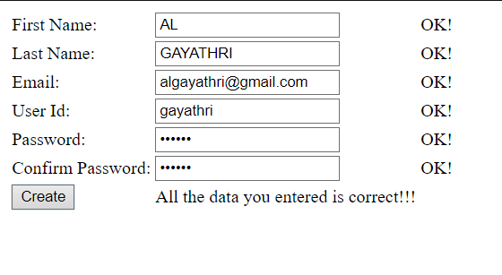

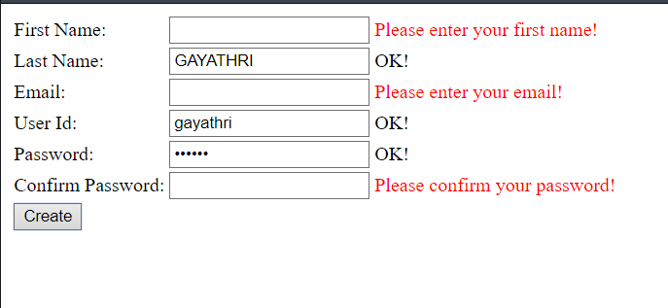

**Experiment No :7**

**REGISTRATION FORM USING PHP AND MySQL**

**AIM:** Using PHP and MySQL develop a program that accepts the registration form, update, delete and display the details.

**SOURCE CODE**

**main.html**

<html>

<head>

<title> homepage </title>

</head>

<body bgcolor="lightgreen">

<center>

<br> <br> <b>

homepage </b> <br><br>

<form method="post" action="insertform.html">

<input type="submit" value="newusers" name="submit">

</form>

<form method="post" action="retrieveform.php">

<input type="submit" value="view registration details" name="submit">

</form>

<form method="post" action="formdelete1.php">

<input type="submit" value="delete" name="submit">

</form>

<form method="post" action="formupdate1.php">

<input type="submit" value="update" name="submit">

</form>

</center>

</body>

</html>

**conn.php**

<?php

$servername='localhost';

$username='root';

$password='';

$dbname="db1";

$conn=mysqli_connect($servername,$username,$password,$dbname); if(!$conn)

{

die('could not connect my sql:' .mysql_error());

}

else

{

echo"database conected";

}

?>

**insertform.html**

<html>

<head>

<title> register form </title>

</head>

<body bgcolor="yellowgreen">

<form method="post" action="insertform.php">

<center> <br> <br>

<b> user registration form <b> <br> <br>

<table>

<tr>

<td> name: </td>

<td><input type="text" name="uname" </td>

</tr>

<tr>

<td> password: </td>

<td> <input type="password" name="pass">

</td>

</tr>

<tr>

<td> gender : </td>

<td>

<input type="radio" name="gen" value="male">male

<input type="radio" name="gen" value="female">female

</td>

</tr>

<tr>

<td> email: </td>

<td><input type="email" name="ema"></td>

</tr>

<tr>

<td> phno: </td>

<td>

<select name="cod">

<option>977</option> <option>978</option> <option>979</option>

<option>973</option> <option>972</option>

<option>974</option>

</select>

<input type="phone" name="phn">

</td>

</tr>

<tr>

<td></td>

<td align="center">

<input type="submit" value="submit" name="submit">

</td>

</tr>

</table>

</form>

</body>

</html>

**insertform.php**

<html>

<body bgcolor="Yellowgreen">

<form action="main.html" method="post">

<center>

<br>

<br>

<?php

include_once 'conn.php';

if(isset($_POST['submit']))

{

$fname=$_POST['uname'];

$passw=$_POST['pass'];

$gen=$_POST['gender'];

$em=$_POST['ema'];

$ph1=$_POST['code'];

$ph2=$_POST['phno'];

$sql="INSERT INTO formtbl(NAME,PASSWORD,GENDER,EMAIL,PHONENUM BER1,PHONENUMBER2)VALUES('$fname','$passw','$gen','$em','$ph1','$ph2')";

if(mysqli_query($conn,$sql))

{

echo "New record created successfully!<br>";

}

else

{

echo "Error:".$sql."".mysqli_error($conn);

}

mysqli_close($conn);

}

?>

<br><br><input type="submit" value="Back to home page" name="submit">

</center>

</body>

</html>

**formdelete1.php**

<head>

<head>

<title> retrive data </title>

</head>

<body bgcolor="lightpink">

<center> <?php include_once 'conn.php';

$sql="SELECT *FROM formtbl"; $result=mysqli_query($conn,$sql); if(mysqli_num_rows($result)>0)

{

?>

<br> <br>

<table border="2">

<tr>

<th> id </th>

<th> name </th>

<th> password </th>

<th> gender </th>

<th> email </th>

<th> phno </th>

</tr>

<?php

$i=0;

while($row=mysqli_fetch_assoc($result))

{ ?>

<tr>

<td> <?php echo $row["id"]; ?></td>

<td> <?php echo $row["name"]; ?></td>

<td> <?php echo $row["password"]; ?></td>

<td> <?php echo $row["gender"]; ?></td>

<td> <?php echo $row["email"]; ?></td>

<td> <?php echo $row["code"]; echo $row["phno"]; ?></td>

</tr>

<?php

$i++;

}

?>

</table>

<br> <br> <br>

<form method="post" action="formdelete2.php"> enter the id to delete : &nbsp&nbsp

<input type="text" name="id">

<br><br>

<input type="submit" name="submit" value="submit">

</form>

<?php

}

else

{

echo "no result found";

}

mysqli_close($conn);

?>

</center>

</body>

</html>

**formdelete2.php**

<html>

<body bgcolor="yellow">

<form action="main.html" method="post">

<center> <?php

include_once 'conn.php';

$rid = $_POST['id'];

$sql="DELETE FROM FORMTBL WHERE id='$rid'"; if (mysqli_query($conn,$sql)) { echo "record deleted successfully";

}

else

{

echo "error deleting record:" .mysqli_error($conn);

}

mysqli_close($conn);

?>

<br>

<br>

<input type="submit" value="back to homepage" name="submit"> </center>

</body> </html> **formupdate1.php** <html>

<head>

<title> retrive data </title>

</head>

<body bgcolor="lightgreen">

<center> <?php include_once 'conn.php';

$sql="SELECT *FROM formtbl"; $result=mysqli_query($conn,$sql); if(mysqli_num_rows($result)>0)

{

?>

<br> <br>

<table border="2">

<tr>

<th> id </th>

<th> name </th>

<th> password </th>

<th> gender </th>

<th> email </th>

<th> phno </th>

</tr>

<?php

$i=0;

while($row=mysqli_fetch_assoc($result)){

?>

<tr>

<td> <?php echo $row["id"]; ?> </td>

<td> <?php echo $row["name"]; ?> </td>

<td> <?php echo $row["password"]; ?> </td>

<td> <?php echo $row["gender"]; ?> </td>

<td> <?php echo $row["email"]; ?> </td>

<td> <?php echo $row["code"]; echo $row["phno"];?> </td>

</tr>

<?php

$i++;

}

?>

</table>

<br> <br> <br>

<form method="post" action="formupdate2.php">

ENTER THE id TO BE updated:&nbsp&nbsp

<input type="text" name="id">

<br> <br>

<input type="submit" name="submit" value="submit">

</form>

<?php

} else {

echo"no record found";

}

mysqli_close($conn);

?>

</center>

</body> </html> **formupdate2.php**

<html>

<head>

<title> update data </title>

</head>

<body bgcolor="cyan">

<form method="post" action="formupdate3.php">

<center> <?php include_once'conn.php';

$rid=$_POST['id'];

$sql="SELECT *FROM formtbl WHERE id='$rid'"; $result=mysqli_query($conn,$sql); if(mysqli_num_rows($result)>0)

{ ?>

<br> <br>

<?php

if($row=mysqli_fetch_assoc($result))

{

?>

Form ID: &nbsp&nbsp<input type="text" value="<?php echo $row["id"];

?> "name="id"> <br> <br>

<b>

Username:&nbsp&nbsp

</b>

<input type="text" value=" <?php echo $row["name"];?>" name="updname"> <br> <br>

<b> password:&nbsp&nbsp

</b>

<input type="text" value=" <?php echo $row["password"];?>" name="updpass"> <br> <br>

<b>

Gender:&nbsp&nbsp

</b>

<input type="radio" name="gender" value="male"<?

if($row["gender"]=="male")

{ echo "checked...";}?>male

<input type="radio" name="gender" value="female"<?

if($row["gender"]=="female")

{ echo "checked...";}?>female

<br> <br>

<b>Email:&nbsp&nbsp

</b>

<input type="text" value="<?php echo $row["email"];?>" name="updemail"><br><br>

<b>

Phone number:&nbsp&nbsp</b>

<select name="code">

<option<?php if($row["code"]=="977"){echo "Selected";}?>>977</option> <option<?php if($row["code"]=="978"){echo "Selected";}?>>978</option>

<option<?php if($row["code"]=="979"){echo "Selected";}?>>979</option> <option<?php if($row["code"]=="972"){echo "Selected";}?>>972</option> <option<?php if($row["code"]=="973"){echo "Selected";}?>>973</option> <option<?php if($row["code"]=="974"){echo "Selected";}?>>974</option>

</select>

<input type="text" value="<?php echo $row["phno"];?>" name="phno"><br><br>

<input type="Submit" value="Update" name="submit">

<?php

}

?>

<?php

}

else

{

echo "No results";

}

?>

</center>

</form>

</body> </html> **formupdate3.php**

<html>

<body bgcolor="lightgreen">

<form action="main.html" method="post">

<center> <?php

include_once 'conn.php'; if(isset($_POST['submit']))

{

$uid=$_POST['id'];

$fname=$_POST['updname'];

$pass=$_POST['updpass'];

$gen=$_POST['gender'];

$ema=$_POST['updemail'];

$code=$_POST['code'];

$phno=$_POST['phno']; $sql="UPDATE formtbl SET

name='$fname',password='$pass',gender='$gen',email='$ema',code='$code',p hno='$phno' where id='$uid'"; if(mysqli_query($conn,$sql)) { echo"update sucessfully ! <br> <br>";

}

else

{

echo"error:" .$sql."".mysqli_error($conn);

}

mysqli_close($conn);

}

?>

<br>

<br>

<input type="submit" value="back to homepage" name="submit">

</center>

</body> </html>

**retrieveform.php**

<html>

<head>

<title>Retrive data</title>

</head>

<body bgcolor="lightpink">

<form action="main.html" method="post">

<center> <?php

include_once'conn.php';

$sql="SELECT * FROM formtbl"; $result=mysqli_query($conn,$sql); if(mysqli_num_rows($result)>0)

{

?>

<br><br>

<table>

<tr>

<th>Id</th>

<th>Name</th>

<th>Password</th>

<th>Gender</th>

<th>Email</th>

<th>Phno</th>

</tr>

<?php

$i=0;

while($row=mysqli_fetch_assoc($result)){

?>

<tr>

<td><?php echo $row["id"];?></td>

<td><?php echo $row["name"];?></td>

<td><?php echo $row["password"];?></td>

<td><?php echo $row["gender"];?></td>

<td><?php echo $row["email"];?></td>

<td><?php echo $row["code"];echo $row["phno"]?></td>

</tr>

<?php

$i++;

}

?>

</table>

<?php

}

else{ echo "No-results"; }

?>

<br><br>

<input type="submit" value="Back to home page" name="submit">

</center>

</form>

</body>

</html>

**RESULT**

The html file is executed and verified.

**OUTPUT**



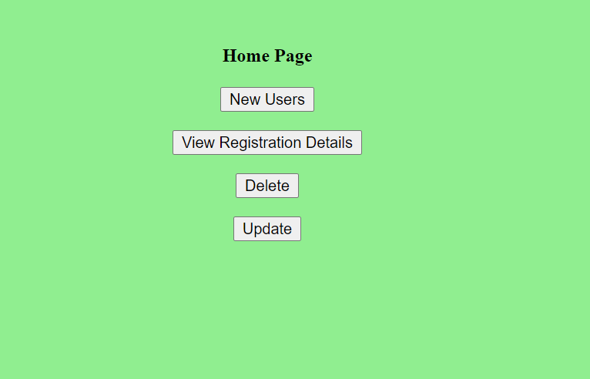

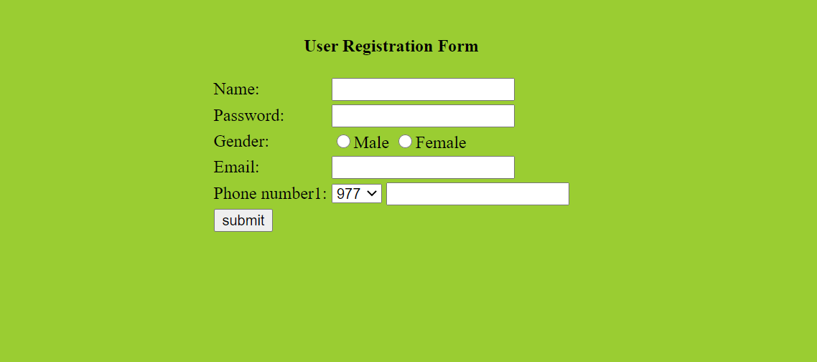

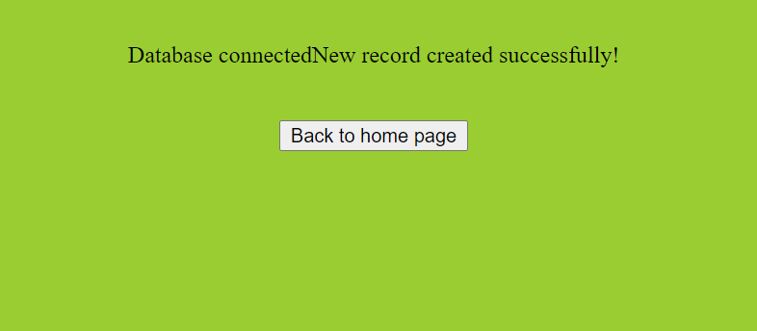

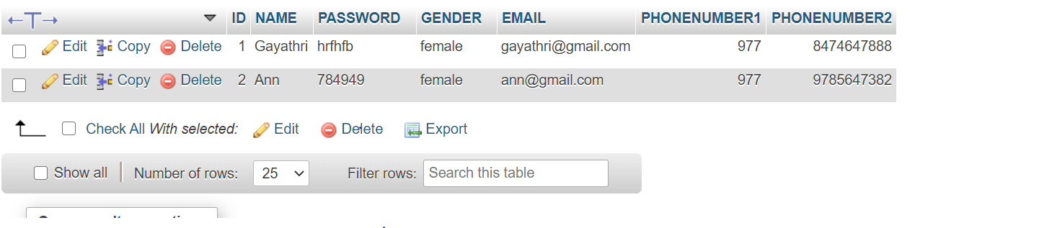

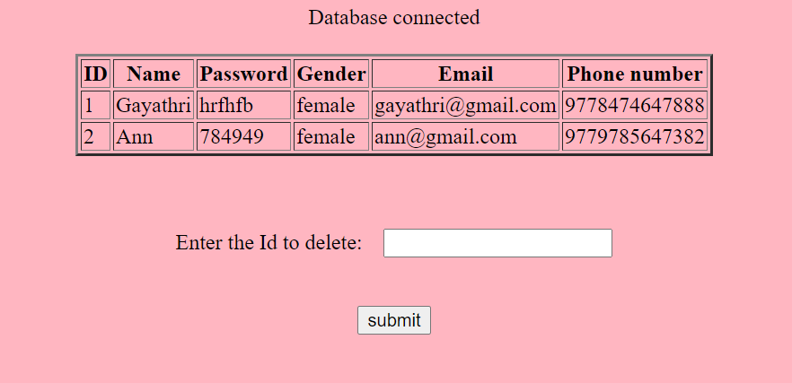



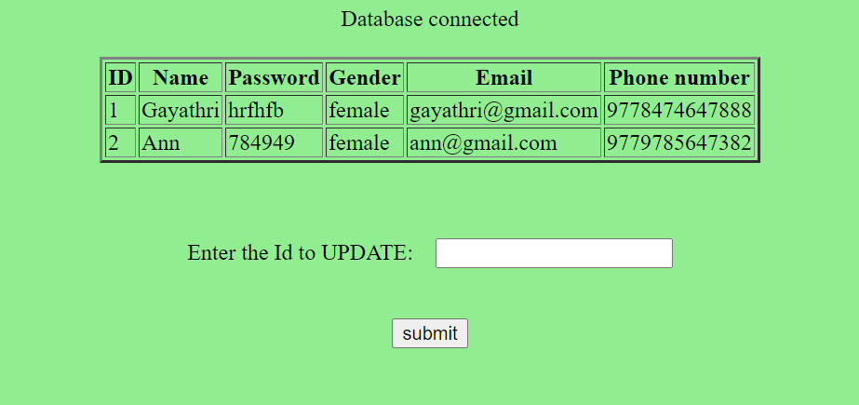

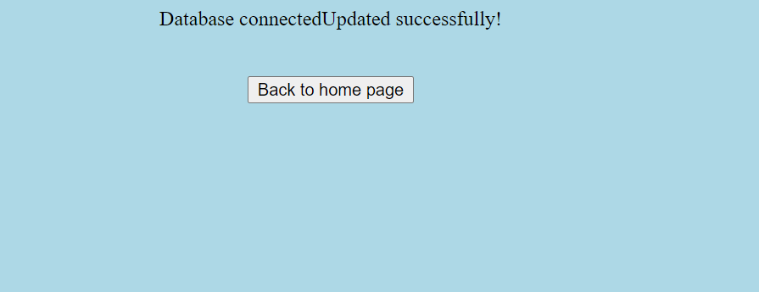

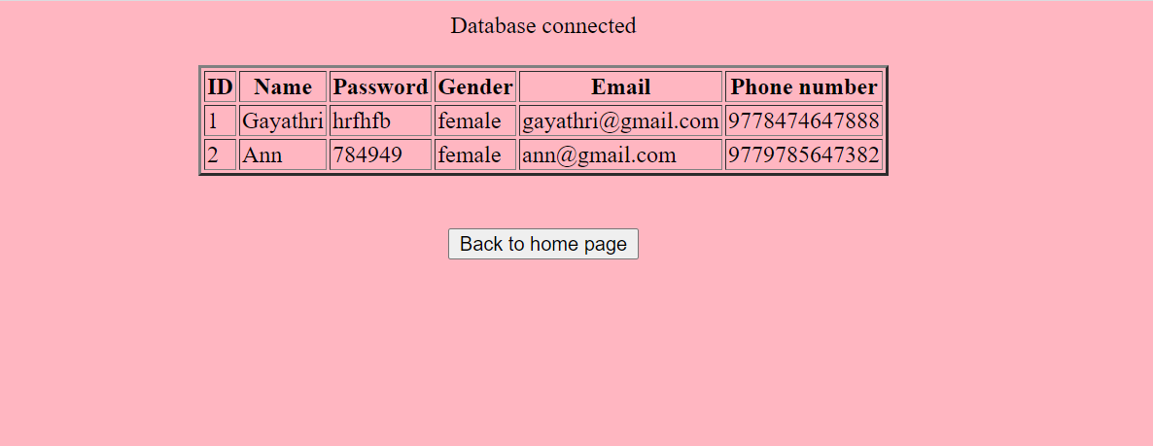

**Experiment No :8**

**EMPLOYEE DETAILS**

**AIM:** Build a PHP code to store the employee details and delete an employee.

**SOURCE CODE :**

**conn.php**

<?php

$servername='localhost';

$username='root';

$password='';

$dbname = "employee";

$conn=mysqli_connect($servername,$username,$password,$dbname); if(!$conn)

{

die('Could not Connect My Sql:' .mysql_error());

}

else

{

echo "Database connected";

}

?>

**Main.html**

<html>

<head>

<title>Employee</title>

</head>

<body bgcolor="cyan">

<center>

<br><br>

<b> Home page</b><br><br>

<form method="post" action="insert.html"><input type="submit" value="New Employee" name="submit">

</form>

<form method="post" action="delete.php">

<input type="submit" value="Delete" name="submit">

</form>

<form method="post" action="view.php">

<input type="submit" value="View" name="submit">

</form>

</center>

</body>

</html>

**Insert.html**

<html>

<head>

<title>Add details</title>

</head>

<body bgcolor="yellow">

<form method="post" action="insert.php">

<center><br><br>

<b>Add Employee details<b><br><br>

<table>

<tr>

<td> Eid:</td>

<td><input type="text"name="id"></td>

</tr>

<tr>

<td>Name :</td> <td><input type="text"name="name"></td>

</tr>

<tr>

<td>Desig:</td>

<td><input type="text"name="desig"></td>

</tr>

<tr>

<td>Salary :</td>

<td><input type="text"name="salary"></td>

</tr>

<tr>

<td><input type="submit" value="submit"name="submit"></td>

</tr>

</table>

</form>

</body> </html> **insert.php**

<html>

<body bgcolor="pink">

<form action="main.html" method="post">

<center>

<br> <br> <?php

include_once 'conn.php'; if(isset($_POST['submit'])){ $eid=$_POST['id'];

$name = $_POST['name'];

$desig=$_POST['desig'];

$salary = $_POST['salary'];

$sql = "INSERT INTO employee (eid,ename,desig,salary) VALUES ('$eid','$name','$desig','$salary')"; if (mysqli_query($conn, $sql)) { echo "<br>New Employee added !<br>";

}

else

{

echo "Error: " . $sql . "" . mysqli_error($conn);

}

mysqli_close($conn);

}

?>

<br><br><input type="submit" value="Back to home page"name="submit">

</center>

</body>

</html>

**delete.php** <html>

<head>

<title> Delete data</title></head>

<body bgcolor="Lightgreen">

<center> <?php include_once 'conn.php';

$sql = "SELECT * FROM employee"; $result=mysqli_query($conn,$sql); if (mysqli_num_rows($result) > 0)

{

?>

<br><br>

<table border="2">

<tr>

<th>Id</th>

<th>Name</th>

<th>Desig</th>

<th>Salary</th>

</tr>

<?php

$i=0;

while($row = mysqli_fetch_assoc($result)) {

?>

<tr>

<td><?php echo $row["eid"]; ?></td>

<td><?php echo $row["ename"]; ?></td>

<td><?php echo $row["desig"]; ?></td>

<td><?php echo $row["salary"]; ?></td></tr>

<?php

$i++;

}

?>

</table>

</tr><br><br><br>

<form method="post" action="delete2.php">

Enter the Id to delete:&nbsp&nbsp

<input type="text" name="id">

<br><br><br>

<input type="submit" name="Submit" value="submit">

</form>

<?php

}

else{ echo "No result found";

}

mysqli_close($conn);

?>

</center>

</body>

</html>

**DELETE2.PHP**

<html>

<body bgcolor="red">

<form action="main.html" method="post">

<center> <?php

include_once 'conn.php';

$rid = $_POST['id'];

$sql = "DELETE FROM employee WHERE eid='$rid'"; if (mysqli_query($conn, $sql)) { echo "Record deleted successfully";

}

else {

echo "Error deleting record: " . mysqli_error($conn);

}

mysqli_close($conn);

?>

<br>

<br>

<input type="submit" value="Back to home page"name="submit">

</center>

</body>

</html>

**VIEW.PHP**

<html>

<head>

<title>"View Employee"</title>

</head>

<body bgcolor="Lightpink"><form action="main.html" method="post">

<center> <?php

include_once 'conn.php';

$sql = "SELECT * FROM employee"; $result=mysqli_query($conn,$sql); if (mysqli_num_rows($result) > 0)

{

?>

<br><br>

<table border="2">

<tr>

<th>Id</th>

<th>Name</th>

<th>Desig</th>

<th>Salary</th>

</tr>

<?php

$i=0;

while($row = mysqli_fetch_assoc($result)) {

?>

<tr>

<td><?php echo $row["eid"]; ?></td>

<td><?php echo $row["ename"]; ?></td>

<td><?php echo $row["desig"]; ?></td>

<td><?php echo $row["salary"]; ?></td></tr>

<?php

$i++;

}

?>

</table>

<?php

}

else{

echo "No result found";

}

?>

<br>

<br>

<input type="submit" value="Back to home page"name="submit">

</center>

</form>

</body>

</html>

**RESULT**

The html file is executed and verified.

**OUTPUT**

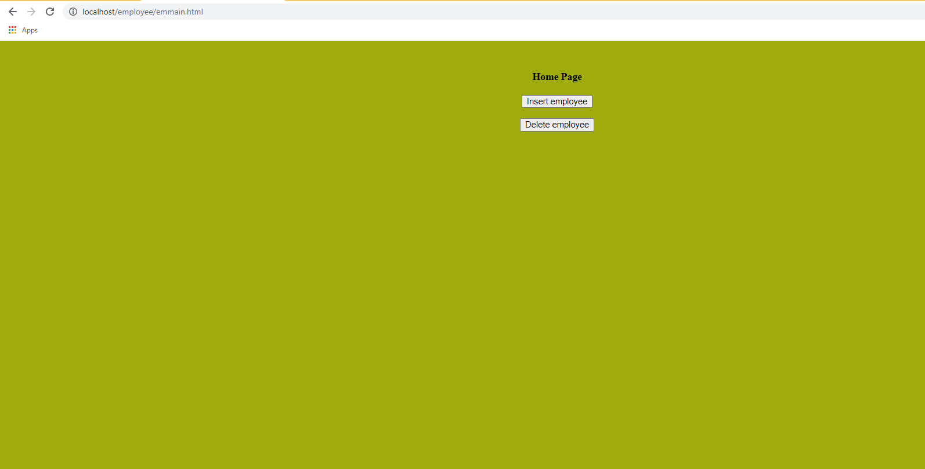



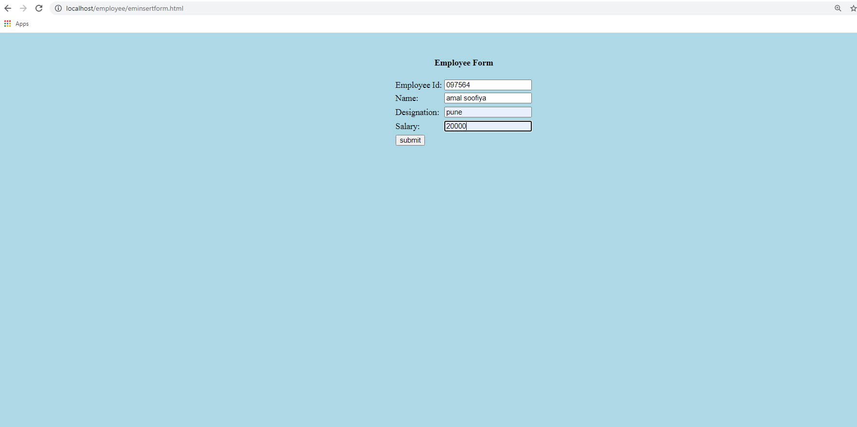

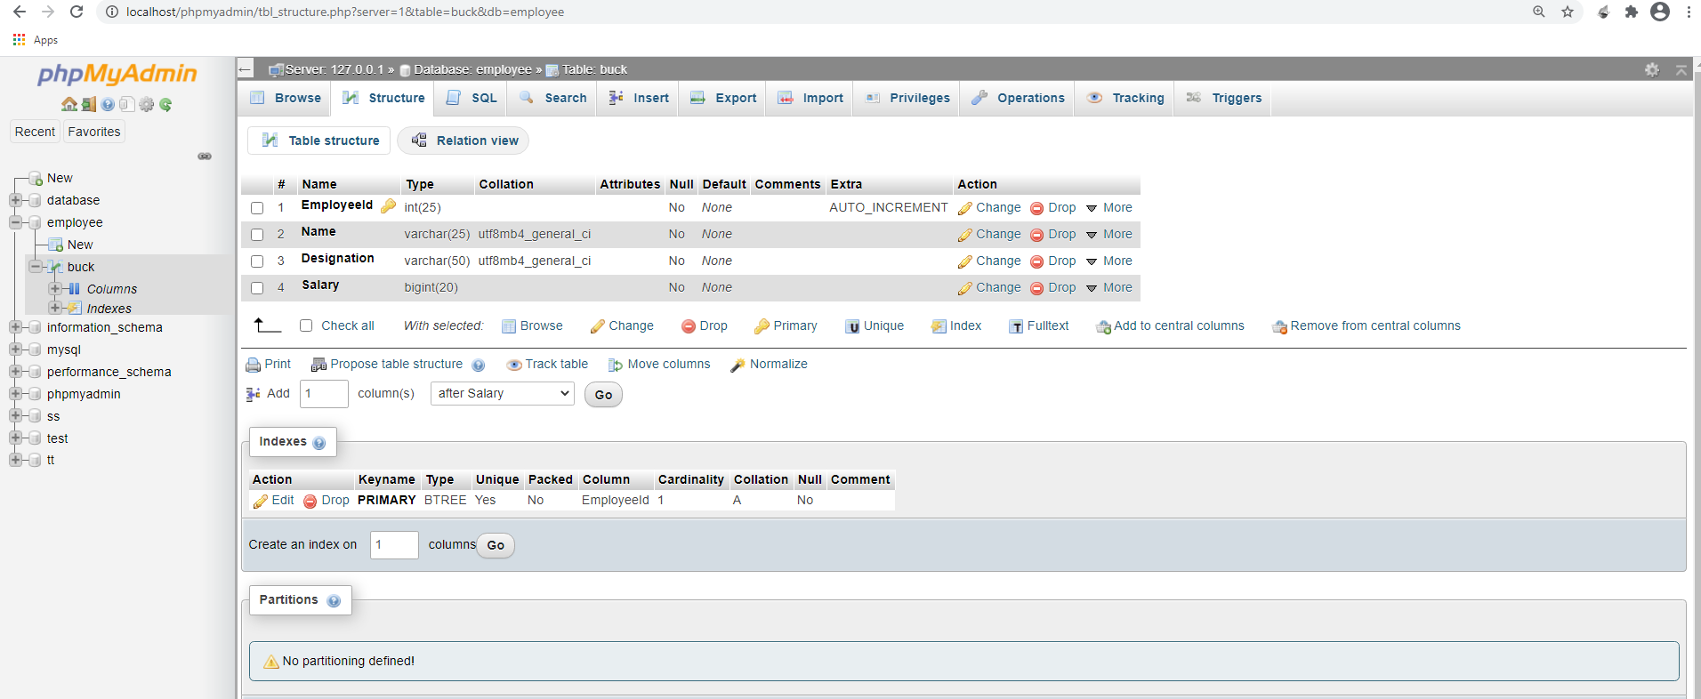

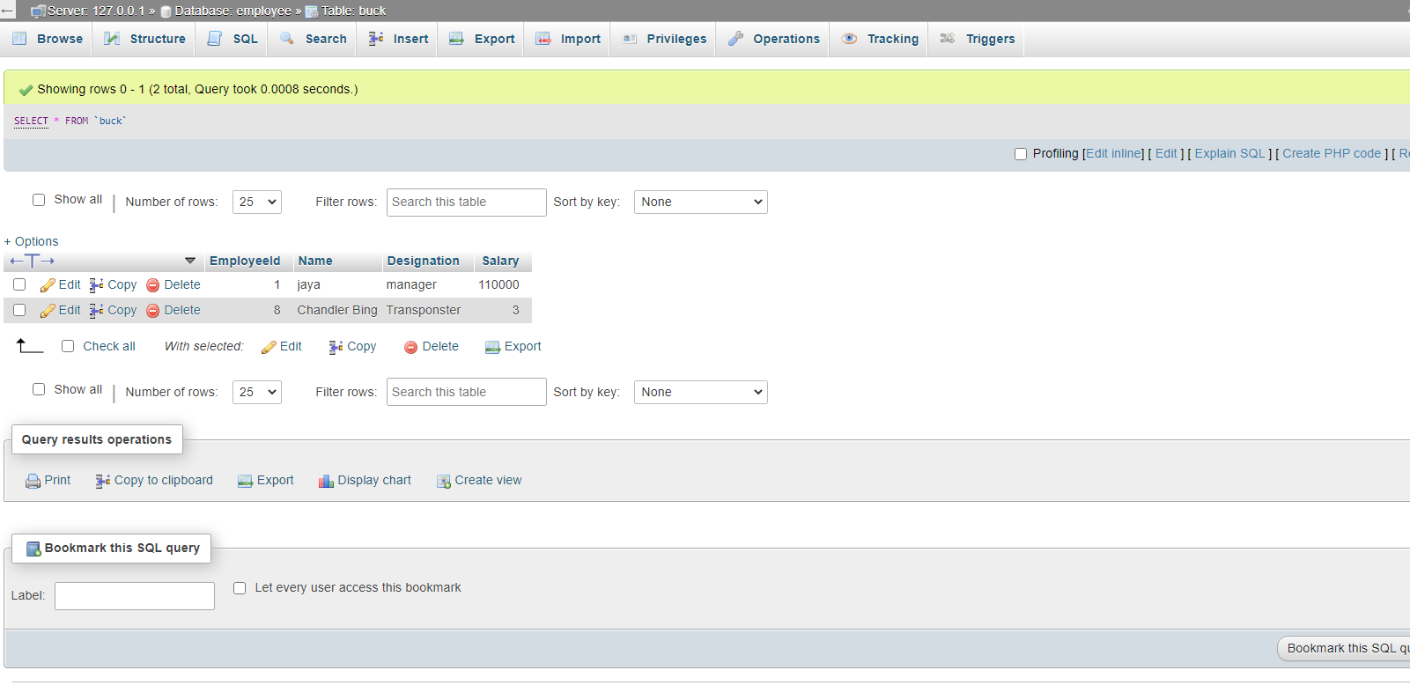

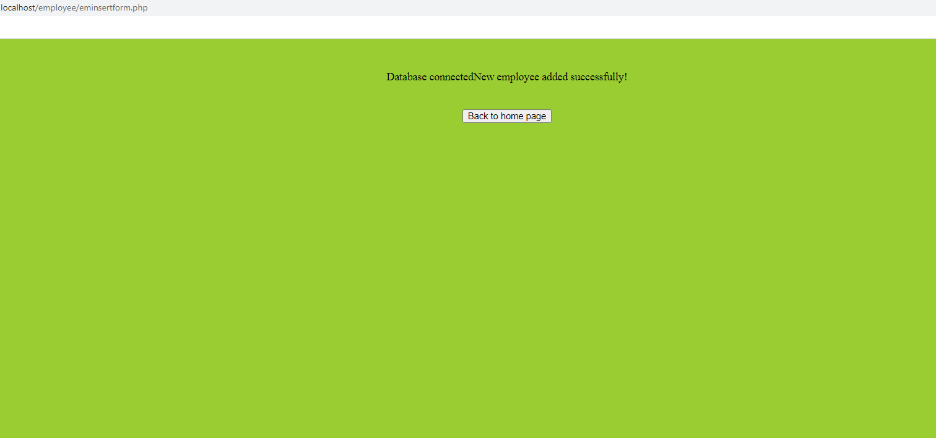

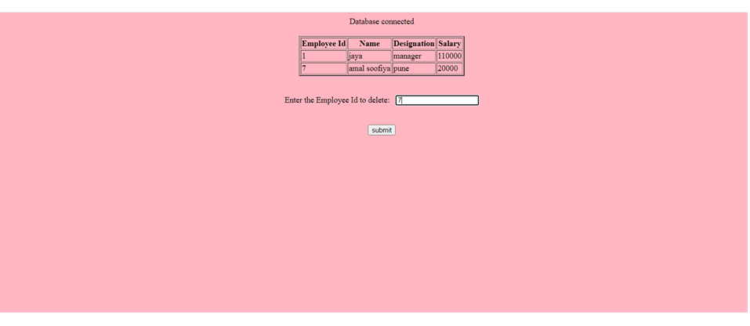



**Experiment No :9**

**BOOK DETAILS**

**AIM:** Develop a web application using PHP to store the book details and view book details.

**SOURCE CODE :**

**CONN.PHP**

<?php

$servername='localhost';

$username='root';

$password='';

$dbname = "library";

$conn=mysqli_connect($servername,$username,$password,$dbname); if(!$conn){

die('Could not Connect My Sql:' .mysql_error());

}

else

{

echo "Database connected";

}

?>

**MAIN.HTML**

<html>

<head>

<title>Homepage</title>

</head>

<body bgcolor="lightblue">

<center><br><br>

<b> Library </b><br><br>

<form method="post" action="insert.html">

<input type="submit" value="Add Book" name="submit">

</form>

<form method="post" action="view.php">

<input type="submit" value="view " name="submit">

</form>

</center>

</body>

</html>

**INSERT.HTML**

<html>

<head>

<title>Add details</title>

</head>

<body bgcolor="cyan">

<form method="post"action="insert.php">

<center><br><br>

<b>Add book details<b><br><br>

<table>

<tr>

<td> Bookid:</td>

<td><input type="text"name="id"></td>

</tr>

<tr>

<td>Title :</td>

<td><input type="text"name="title"></td>

</tr>

<tr>

<td>Author:</td>

<td><input type="text"name="author"></td>

</tr>

<tr>

<td>Publisher :</td>

<td><input type="text"name="pub"></td>

</tr>

<tr>

<td>Price:</td>

<td><input type="text"name="price"></td>

</tr>

<td>Quantity:</td>

<td><input type="text"name="qty"></td>

</tr>

<tr>

<td><input type="submit" value="submit"name="submit"></td>

</tr>

</table>

</form>

</body>

</html>

**INSERT.PHP**

<html>

<body bgcolor="Yellowgreen">

<form action="main.html" method="post">

<center>

<br> <br> <?php

include_once 'conn.php'; if(isset($_POST['submit']))

{

$bookid=$_POST['id'];

$title = $_POST['title'];

$author=$_POST['author'];

$publisher = $_POST['pub'];

$price=$_POST['price'];

$quantity = $_POST['qty'];

$sql = "INSERT INTO library

(bookid,title,author,publisher,price,quantity)

VALUES

('$bookid','$title','$author','$publisher','$price','$quantity')";

if (mysqli_query($conn, $sql)) {

echo "<br>New Book added !<br>";

} else

{

echo "Error: " . $sql . "" . mysqli_error($conn);

}

mysqli_close($conn);

}

?>

<br><br><input type="submit" value="Back to home page"name="submit">

</center>

</body>

</html>

**VIEW.PHP**

<html>

<head>

<title>"View Book"</title>

</head>

<body bgcolor="Lightpink">

<form action="main.html" method="post">

<center>

<?php

include_once 'conn.php';

$sql = "SELECT * FROM library"; $result=mysqli_query($conn,$sql); if (mysqli_num_rows($result) > 0)

{

?>

<br><br>

<table border="2">

<tr>

<th>BookId</th>

<th>Title</th>

<th>Author</th>

<th>Publisher</th>

<th>Price</th>

<th>Quantity</th>

</tr>

<?php

$i=0;

while($row = mysqli_fetch_assoc($result)) {

?>

<tr>

<td><?php echo $row["Bookid"]; ?></td>

<td><?php echo $row["Title"]; ?></td>

<td><?php echo $row["Author"]; ?></td>

<td><?php echo $row["Publisher"]; ?></td> <td><?php echo $row["Price"]; ?></td>

<td><?php echo $row["Quantity"]; ?></td>

</tr>

<?php

$i++;

}

?>

</table>

<?php

}

else{

echo "No result found";

}

?>

<br>

<br>

<input type="submit" value="Back to home page"name="submit">

</center>

</form>

</body>

</html>

**RESULT**

The html file is executed and verified.

**OUTPUT**

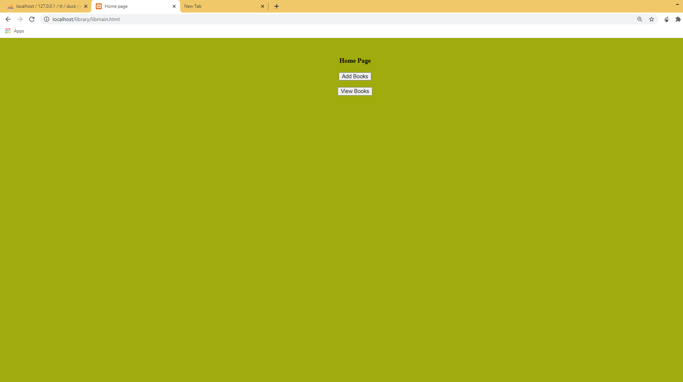



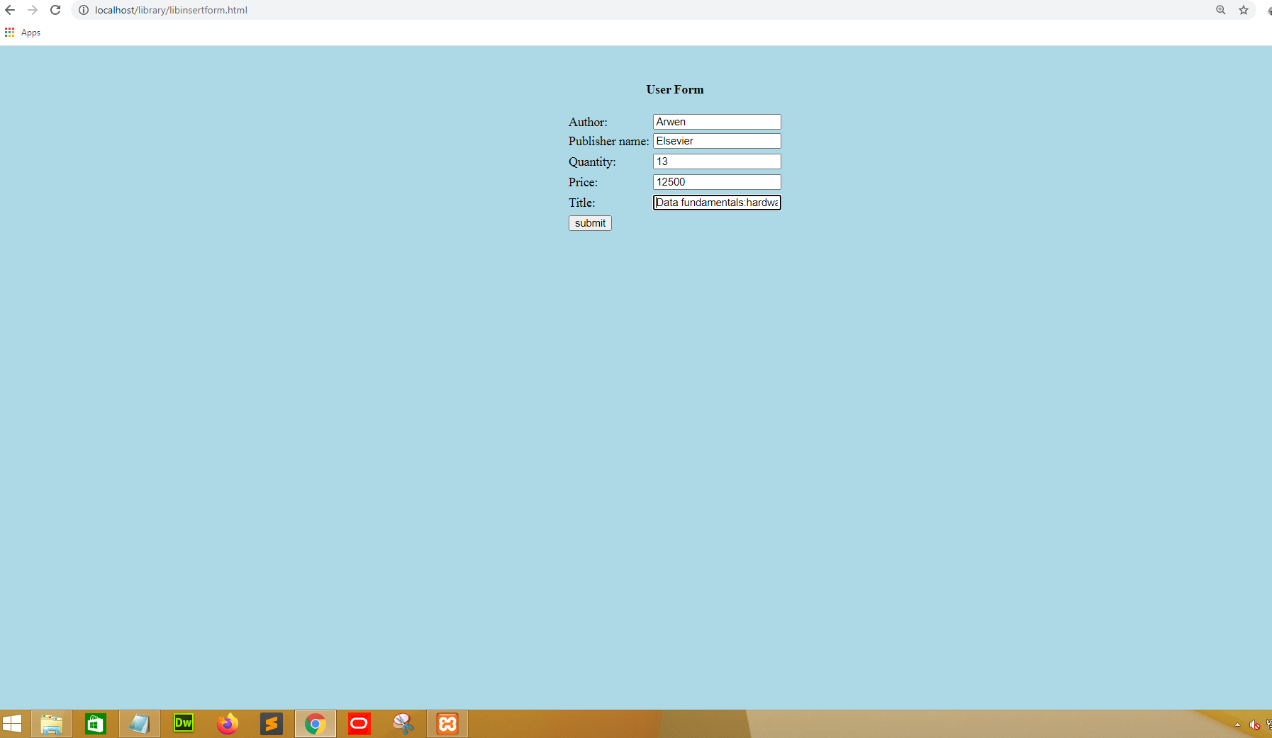

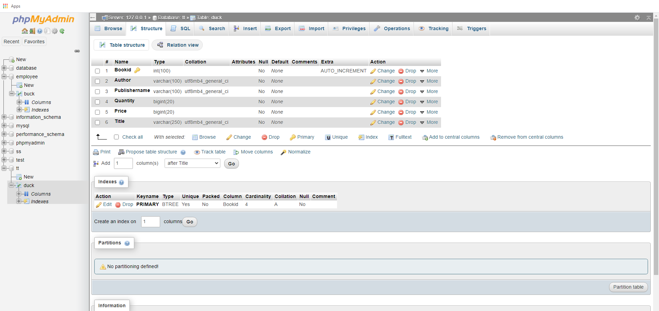

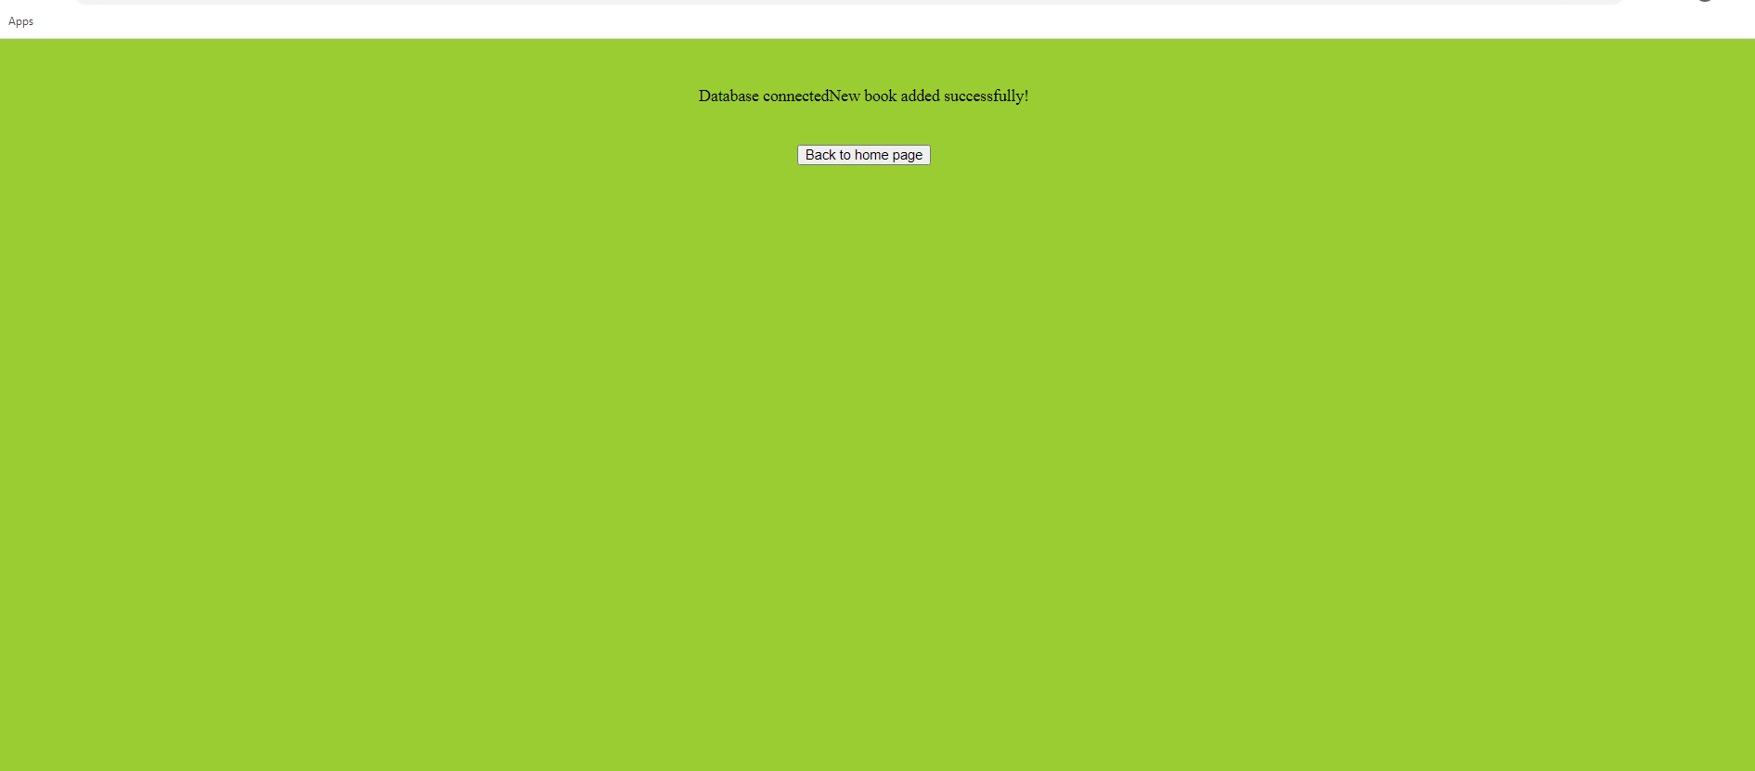

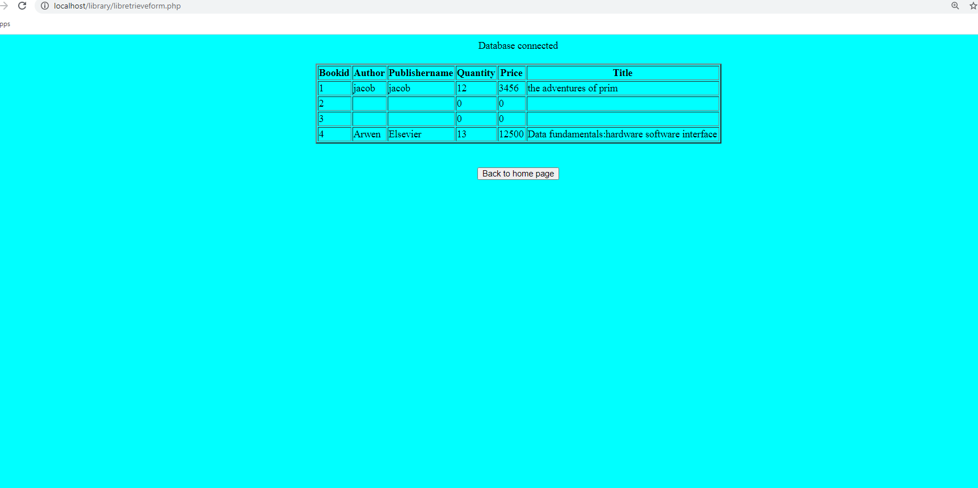

**Experiment No :10**

**PRODUCT**

**AIM:** Using PHP develop a program that accepts few products and also view the products to the users.

**SOURCE CODE :**

**Conn1.php**

<?php

$servername='localhost';

$username='root';

$password='';

$dbname = "users";

$conn=mysqli_connect($servername,$username,$password,$dbname); if(!$conn){

die('Could not Connect My Sql:' .mysql_error());

}

?>

**Login.php**

<html>

<head>

<title>LOGIN PAGE</title>

<link rel="stylesheet" type="text/css" href="css1.css">

<script src="https://kit.fontawesome.com/d69e372328.js" crossorigin="anonymous"></script>

</head>

<body>

<div class="loginbox">

<center>

<i class="fas fa-user-circle fa-5x"></i><br><br><br>

<h1>LOGIN</h1><br><br>

<form method="POST" action="connect.php" >

<p>Username</p>

<input type="email" name="email" placeholder="Enter username or gmail id"><br><br>

<p>Password</p>

<input type="password" name="password" placeholder="Enter Password">

<br><br>

<input type="submit" name="submit" value="LOGIN">

<br>

<a href="signup.html">Don't have an account?SignUp</a>

</form>

</center>

</div>

</body>

</html>

**css1.css** body

{

margin :0; padding : 0;

background: url(img1.jpg); background-size:cover; background-position : center;

}

font-family : sans-serif;

.loginbox

{

width: 340px; height:440px; background: rgb(0, 0, 0); color:#fff; top:50%; left:50%; position:absolute; transform:translate(-50%,-50%); box-sizing:border-box; border-radius: 20px;

}

h1

{

margin:0; padding : 0 0 20px; text-align:center; font-size:22px;

}

.loginbox i

{ top: 5px; position: absolute; transform:translate(-50%,-50%);

.loginbox p

{

margin: 0; padding-left:30px; font-weight:bold; text-align: left; margin-left: 8px;

}

.loginbox input

{

width : 75%; margin-bottom:20px; padding-left:25px; text-align: left; margin-left: 5px;

}

.loginbox input[type="text"],input[type="password"],input[type="email"]

{

border:none; border-bottom:1px solid; background: transparent; outline :none; height:40px; color:#fff;

font-size:16px;

.loginbox input[type="submit"]

{

border-radius: 20px; outline:none; height:40px; width:130px; background: #d80505;

color: #fff; font-size: 18pxs; text-align: center; padding-left: 10px;

}

.loginbox input[type="submit"]:hover

{

cursor: pointer; background :green; color:#000;

}

.loginbox a{ text-decoration: none; font-size: 12px; line-height:20px; color:white;

}

.loginbox a:hover

{

color:red;} **connect.php** <?php

include_once 'conn1.php'; if(isset($_POST['submit']))

{

$em=$_POST['email'];

$pass=$_POST['password'];

$sql = "Select * from users where EMAIL_ID='$em' AND PASSWORD='$pass'";

$result=mysqli_query($conn,$sql); if (mysqli_num_rows($result)==1)

{

header("location:view.php"); }

$sq="Select * from admin where EMAIL_ID='$em' AND PASSWORD='$pass'";

$res=mysqli_query($conn,$sq); if (mysqli_num_rows($res)==1)

{

header("location:add.php");

}

else{

echo "No result found";

}

mysqli_close($conn); }

?>

**Css2.css** body

{

margin :0; padding : 0; background: url(img1.jpg); background-size:cover; background-position : center; font-family : sans-serif;

}

.loginbox

{

width: 390px; height:590px; background: rgb(0, 0, 0); color:#fff; top:52%; left:50%; position:absolute; transform:translate(-50%,-50%); box-sizing:border-box; border-radius: 20px;

}

h1

{

margin:0; padding : 0 0 20px; text-align:center; font-size:22px;

}

.loginbox i

{ top: 5px; position: absolute; transform:translate(-50%,-50%);

}

.loginbox p

{

margin: 0; padding-left:30px; font-weight:bold; text-align: left; margin-left:15px;

}

.loginbox input

{

width : 70%; margin-bottom:20px;

text-align: left; margin-left: -10px;

}

.loginbox input[type="text"],input[type="password"],input[type="email"]

{

border:none; border-bottom:1px solid; background: transparent; outline :none; height:40px; color:#fff; font-size:16px;

}

#type

{

border:1px solid #fff; background: transparent; font-size:16px; color:#fff; height:30px; width: 180px; border-radius: 10px; padding-left:30px; margin-left: -90px;

}

.loginbox input[type="submit"]

{

border-radius: 20px; outline:none; height:40px; width:130px; background: #d80505;

color: #fff; font-size: 18pxs; text-align: center;

}

.loginbox input[type="submit"]:hover

{

cursor: pointer; background :#ffc107; color:#000;

}

.loginbox a{ text-decoration: none; font-size: 12px; line-height:20px; color:darkgrey;

}

.loginbox a:hover

{

color:#ffc107;

}

.message

{

text-align: center; bottom:5px;

}

.loginbox a{ text-decoration: none; font-size: 12px; line-height:20px; color:white;

}

.loginbox a:hover

{

color:red;

}

**Insert.php**

<html>

<head>

<title>SIGNUP</title>

<link rel="stylesheet" type="text/css" href="css2.css">

<script src="https://kit.fontawesome.com/d69e372328.js" crossorigin="anonymous"></script>

</head>

<body>

<div class="loginbox">

<center>

<i class="fas fa-user-circle fa-5x"></i><br><br><br>

<h1>SIGN UP</h1><br><br>

<p>Name</p>

<input type="text" name="name" placeholder="Enter your name"><br> <p>Email id</p>

<input type="email" name="email" placeholder="Enter your email id">

<p>Password</p>

<input type="password" name="password" placeholder="Enter your password">

<br>

<input type="submit" value="Sign Up" name="submit">

<br>

<a href="login.html">Already have an account?Login</a><br><br>

</center>

<div class="message">

<?php

include_once 'conn1.php'; if(isset($_POST['submit']))

{

$name = $_POST['name'];

$em=$_POST['email'];

$pass=$_POST['password'];

$sql = "INSERT INTO users(NAME,EMAIL_ID,PASSWORD) VALUES ('$name','$em','$pass')"; if (mysqli_query($conn, $sql))

{

echo "Successfully Signed Up !!<br>";

} else

{

echo "Error: " . $sql . "" . mysqli_error($conn);

}

mysqli_close($conn);

}

?>

</div>

</form>

</div>

</body>

</html>

**Add.php**

<html>

<head>

<title>HOME PAGE</title>

<link rel="stylesheet" type="text/css" href="css2.css">

<script src="https://kit.fontawesome.com/d69e372328.js" crossorigin="anonymous"></script>

</head>

<body>

<center> <br><br>

<form method="post"action="viewuser.php">

<input type="submit" value="View Users" name="submit">

</form>

<form method="post"action="insertitem.html">

<input type="submit" value="Insert Product" name="submit">

</form>

<form method="post"action="itemdelete1.php">

<input type="submit" value="Delete Product" name="submit">

</form>

<form method="post"action="itemupdate1.php">

<input type="submit" value="Update Product" name="submit">

</form>

<form method="post"action="view.php">

<input type="submit" value="View Product" name="submit">

</form>

</center>

</body>

</html>

**Insertitem.html**

<html>

<head>

<title>Add products</title>

</head>

<body bgcolor="Yellowgreen">

<form method="post" action="insertitem.php">

<center><br><br>

<b>ADD PRODUCTS<b><br><br>

<table>

<tr>

<td>Product Id :</td>

<td><input type="text" name="id"></td>

</tr>

<tr>

<td>Product Name :</td>

<td><input type="text" name="name"></td>

</tr>

<tr>

<td>Price :</td>

<td><input type="text" name="price"></td>

</tr>

<td>Quantity :</td>

<td><input type="text" name="qty"></td>

</tr>

<tr>

<td><input type="submit" value="submit" name="submit"></td>

</tr>

</table>

</form>

</body>

</html>

**Insertitem.php**

<html>

<body bgcolor="Yellowgreen">

<form action="add.php" method="post">

<center>

<br>

<br> <?php

include_once 'conn1.php'; if(isset($_POST['submit']))

{

$name = $_POST['name'];

$price=$_POST['price'];

$qty= $_POST['qty'];

$sql = "INSERT INTO item(item_name,price,quantity) VALUES

('$name','$price','$qty')"; if (mysqli_query($conn, $sql)) {

echo "New Item added !<br>";

} else

{

echo "Error: " . $sql . "" . mysqli_error($conn);

}

mysqli_close($conn);

}

?>

<br><br><input type="submit" value="Back to home page" name="submit">

</center>

</body>

</html>

**Viewuser.php**

<?php

include_once 'conn1.php';

$sql = "SELECT * FROM users"; $result=mysqli_query($conn,$sql); if (mysqli_num_rows($result) > 0)

{

?>

<html>

<head>

<title> View Users</title>

<style>

body

{

background: url(img3.jpg);

}

.loginbox

{

width: 540px; height:340px; background: black; top:50%; left:50%; position:absolute; transform:translate(-50%,-50%); box-sizing:border-box; border-radius: 20px;

}

table

{

color:white;

}

</style>

</head>

<body >

<div class="loginbox">

<form action="#" method="post">

<center>

<br><br>

<table border="2" >

<tr>

<th>Id</th>

<th>User Name</th>

<th>Email id</th>

</tr>

<?php

$i=0;

while($row = mysqli_fetch_assoc($result)) {

?>

<tr>

<td><?php echo $row["ID"]; ?></td>

<td><?php echo $row["NAME"]; ?></td>

<td><?php echo $row["EMAIL_ID"]; ?></td>

</tr>

<?php

$i++;

}

?>

</table>

<?php

}

else{

echo "No result found";

}

?>

<br>

<br>

</center>

</form>

</div>

</body>

</html>

**Itemdelete1.php**

<html>

<head>

<title> Product List</title>

</head>

<body bgcolor="Lightpink">

<center>

<?php

include_once 'conn1.php';

$sql = "SELECT * FROM item"; $result=mysqli_query($conn,$sql); if (mysqli_num_rows($result) > 0)

{

?>

<br><br>

<table border="2">

<tr>

<th>Id</th>

<th>item Name</th>

<th>Price</th>

<th>Quantity</th>

</tr>

<?php

$i=0;

while($row = mysqli_fetch_assoc($result)) {

?>

<tr>

<td><?php echo $row["id"]; ?></td>

<td><?php echo $row["item_name"]; ?></td>

<td><?php echo $row["price"]; ?></td>

<td><?php echo $row["quantity"]; ?></td>

</tr>

<?php

$i++;

}

?>

</table>

</tr><br><br><br>

<form method="post" action="itemdelete2.php">

Enter the Id to delete:&nbsp&nbsp

<input type="text" name="id">

<br><br><br>

<input type="submit" name="Submit" value="submit">

</form>

<?php

}

else{

echo "No result found";

}

mysqli_close($conn);

?>

</center>

</body>

</html>

**Itemdelete2.php**

<html>

<body bgcolor="Yellow">

<form action="add.php" method="post">

<center> <?php include_once 'conn1.php';

$rid = $_POST['id'];

$sql = "DELETE FROM item WHERE id='$rid'";

if (mysqli_query($conn, $sql)) { echo "Record deleted successfully";

}

else {

echo "Error deleting record: " . mysqli_error($conn);

}

mysqli_close($conn);

?>

<br>

<br>

<input type="submit" value="Back to home page"name="submit">

</center>

</body>

</html>

Itemupdate1.php

<html>

<head>

<title>Item Update</title>

</head>

<body bgcolor="Lightgreen">

<center>

<?php

include_once 'conn1.php';

$sql = "SELECT * FROM item"; $result=mysqli_query($conn,$sql); if (mysqli_num_rows($result) > 0)

{

?>

<br><br>

<table border="2">

<tr>

<th>Id</th>

<th>Name</th>

<th>Price</th>

<th>Quantity</th>

</tr>

<?php

$i=0;

while($row = mysqli_fetch_assoc($result)) {

?>

<tr>

<td><?php echo $row["id"]; ?></td>

<td><?php echo $row["item_name"]; ?></td>

<td><?php echo $row["price"]; ?></td>

<td><?php echo $row["quantity"]; ?></td>

</tr>

<?php

$i++;

}

?>

</table>

</tr><br><br><br>

<form method="post" action="itemupdate2.php">

Enter the Id to Update:&nbsp&nbsp

<input type="text" name="id">

<br><br><br>

<input type="submit" name="Submit" value="submit">

</form>

<?php

}

else{

echo "No result found";

}

mysqli_close($conn);

?>

</center>

</body>

</html>

**Itemupdate1.php**

<html>

<head>

<title>Item Update</title>

</head>

<body bgcolor="Lightgreen">

<center>

<?php

include_once 'conn1.php';

$sql = "SELECT * FROM item"; $result=mysqli_query($conn,$sql); if (mysqli_num_rows($result) > 0)

{

?>

<br><br>

<table border="2">

<tr>

<th>Id</th>

<th>Name</th>

<th>Price</th>

<th>Quantity</th>

</tr>

<?php

$i=0;

while($row = mysqli_fetch_assoc($result)) {

?>

<tr>

<td><?php echo $row["id"]; ?></td>

<td><?php echo $row["item_name"]; ?></td>

<td><?php echo $row["price"]; ?></td>

<td><?php echo $row["quantity"]; ?></td>

</tr>

<?php

$i++;

}

?>

</table>

</tr><br><br><br>

<form method="post" action="itemupdate2.php">

Enter the Id to Update:&nbsp&nbsp

<input type="text" name="id">

<br><br><br>

<input type="submit" name="Submit" value="submit">

</form>

<?php

}

else{

echo "No result found";

}

mysqli_close($conn);

?>

</center>

</body>

</html>

**Itemupdate2.php**

<html>

<head>

<title> Item update</title>

</head>

<body bgcolor="cyan">

<form method="post" action="itemupdate3.php">

<center> <?php include_once 'conn1.php';

$rid = $_POST['id'];

$sql = "SELECT * FROM item where id='$rid'";

$result=mysqli_query($conn,$sql);

if (mysqli_num_rows($result) > 0)

{

?>

<br><br>

<?php

if($row = mysqli_fetch_assoc($result)) {

?>

Id:&nbsp&nbsp <input type="text" value="<?php echo $row["id"]; ?>" name="id"><br><br>

<b

>Product Name &nbsp&nbsp</b>

<input type="text" value="<?php echo $row["item_name"]; ?>" name="pname"><br><br>

<b>Price &nbsp&nbsp</b>

<input type="text" value="<?php echo $row["price"]; ?>" name="price"><br><br>

<b>Quantity &nbsp&nbsp</b>

<input type="text" value="<?php echo $row["quantity"]; ?>" name="qty"><br><br>

<input type="Submit" value="Update" name="submit" >

<?php

}

?>

<?php

}

else{

echo "No result found";

}

?>

</center>

</form>

</body>

</html>

**Itemupdate3.php**

<html>

<body bgcolor="Lightblue">

<form action="add.php" method="post">

<center> <?php

include_once 'conn1.php'; if(isset($_POST['submit']))

{

$uid=$_POST['id'];

$fname = $_POST['pname'];

$pass=$_POST['price'];

$em=$_POST['qty'];

$sql = "UPDATE item SET

item_name='$fname',price='$pass',quantity='$em' where id='$uid'";

if (mysqli_query($conn, $sql)) { echo "Updated successfully !<br><br>";

} else

{

echo "Error: " . $sql . "" . mysqli_error($conn);

}

mysqli_close($conn);

}

?>

<br>

<br>

<input type="submit" value="Back to home page"name="submit">

</center>

</body>

</html>

**View.php**

<?php

include_once 'conn1.php';

$sql = "SELECT * FROM item"; $result=mysqli_query($conn,$sql); if (mysqli_num_rows($result) > 0)

{

?>

<html>

<head>

<title> View Items</title>

<style> body

{

background: url(img3.jpg);

}

.loginbox

{

width: 540px; height:340px; background: black; top:50%; left:50%; position:absolute; transform:translate(-50%,-50%); box-sizing:border-box; border-radius: 20px;

}

table

{

color:white;

}

</style>

</head>

<body >

<div class="loginbox">

<form action="#" method="post">

<center>

<br><br>

<table border="2" >

<tr>

<th>Id</th>

<th>Item Name</th>

<th>Price</th>

<th>Quantity</th>

</tr>

<?php

$i=0;

while($row = mysqli_fetch_assoc($result)) {

?>

<tr>

<td><?php echo $row["id"]; ?></td>

<td><?php echo $row["item_name"]; ?></td>

<td><?php echo $row["price"]; ?></td>

<td><?php echo $row["quantity"]; ?></td>

</tr>

<?php

$i++;

}

?>

</table>

<?php

}

else{

echo "No result found";

}

?>

<br>

<br>

</center>

</form>

</div>

</body>

</html>

**RESULT**

The html file is executed and verified.

**OUTPUT**



